

**Coastal Marine Health Recommendation System (MHRS)**

**Team Matrix**

**Jay Bhorania**

**Kavish Jain**

**Ritvick Paliwal**

**Maitry Shah**

**Under the guidance:**

**Prof. Chandrasekar Vuppalapati**

**Website Link**: https://cmpe239.mybluemix.net/

**Github Link:** https://github.com/ritvick/cmpe239

Table of contents

**Description****2**

**Requirements****5**

**UI Design Principles****6**

**High Level Architecture Design****8**

**Datasets & Data patterns****9**

**Data Flow Diagrams & Architecture****14**

**Data Mining Principles & Algorithms****17**

**KDD Principles****22**

**Data Tools Used****24**

**Client Side Design****25**

**Testing (UI or Stress test)****29**

**Design Patterns Used****34**

**Presentation****36**

**Team Contribution****40**

### Description

There are many kind of oceanic parameters that can affect the health of marine ecosystem, this ecosystem in turn affects the health of sea plants and animals. Data mining techniques can help to analyse this vast variety of data to find correlation and Frequently occurring news stories about toxin contamination of sea animals in california coastal region has become common. The oceanic parameters are regularly recorded by CeNCOOS. CeNCOOS is the Central and Northern California Ocean Observing System, it is part of a national framework of integrated coastal observing systems covering all coastal areas throughout the United States. This national framework is called the Integrated Ocean Observing System (IOOS). The regional extent of CeNCOOS includes from Point Conception north to the California-Oregon border, from the coastline out to 200 nautical miles (the seaward extent of the Exclusive Economic Zone) and includes bays and estuaries in this region.

A. Dissolved oxygen

In freshwater Dissolved oxygen is a critical parameter refers to the level of free, non-compound oxygen present in water or other liquids. It is an important parameter in assessing water quality because of its influence on the organisms living within a body of water. In limnology (the study of lakes), dissolved oxygen is an essential factor second only to water itself. A dissolved oxygen level that is too high or too low can harm aquatic life and affect water quality. The cold water fish like trout and salmon are mostly affected by low dissolved oxygen levels 19 mg/L. The mean DO level for adult salmonids is 6.5 mg/L and the minimum DO level is 4 mg/L. These fish will die if they are exposed to DO levels less than 3 mg/L for more than two days.For the DO levels less than 11 mg/L will delay the hatching of salmon and trout eggs. For levels below 8 mg/L will impair the growth and reduce their survival rates. When dissolved oxygen reduces less than 6 mg/L, the vast majority of trout and salmon eggs will die.

B. Dissolved oxygen

In salt water Saltwater has 100 percent saturation than fresh water. Saltwater fish and organisms have a higher tolerance for low dissolved oxygen concentrations. The DO levels dissolved oxygen levels are 20 percent less in seawater than in freshwater. This does not implies that saltwater fish can live without dissolved oxygen completely. Striped bass, white perch. Billfish swim in areas with a DO level of 3.5 mg/L, while marlins and sailfish dive with DO levels of 1.5 mg/L . Major tropical saltwater fish like clown fish, angel fish and groupers require higher levels of DO, such as those surrounding coral reefs. The requirements of DO levels fluctuate around 4-9 mg/L. Crabs, oysters, lobsters, mussels and other bottom dwellers which are found in shallower or coastal waters require a minimum of 4 mg/L to 1 mg/L.

C. pH Level

pH of water is a figure ranging from 0 to 14 defining how the basicity or acidity of water and not a physical quantity we can measure. The aquatic organisms will die if the pH of water is too high or too low. A preferable pH value is around 6.5-9.0 for majority of aquatic animals. As pH levels move up and down from this range it can increase the stress in animal systems and delay hatching and increase survival rates. The higher the variation of pH value from the favorable rate, the higher the mortality rates. Sensitive species are more affected by changes in pH. Extreme pH levels increase the solubility of elements and compounds which makes the toxic chemicals more mobile and increasing the risk of absorption by aquatic life.

D. Salinity

The salinity is the total concentration of all dissolved salts in water. The acquatic animals can tolerate only specific salinity range. The fishes like stenohaline or saltwater or freshwater. The euryhaline organisms are either anadromous, catadromous or truly euryhaline. They spawn in fresh water while they live in salt water. The catadromous species are opposite, they live in fresh water while spawn in salt water. True euryaline live in fresh water or salt water. Salinity is important as it affects dissolved oxygen solubility. The salinity effects is directly proportional to the dissolved oxygen as given by Henrys law. The higher the salinity the lower the dissolved oxygen.Dissolved oxygen levels decreases its solubility by 80 percent in seawater than in freshwater at the same temperature which means that seawater has a lower dissolved oxygen concentration than freshwater source.

E. Carbon Dioxide

When the level of CO2 increases the carbon dioxide reacts chemically with water and produces carbonic acid (H2CO3) which in turn increases the acidity (lowers the pH) of seawater. Decrease in the pH levels results in stressing the marine healthlife of corals and other calcifying marine organisms. Other marine species like lobsters, snails, starfish, oysters, clams, and various species of phytoplankton produce their food through photosynthesis. Increase in CO2 results in overproduction of phytoplankton which is also known as algae boom. It can cause toxic red tides and fish kills.

F. Temperature

After Dissolved oxygen, temperature is an important factor that affects the marine life health. Warm water and cold water species have different temperature preferences and tolerances. Fishes like lake trout can survive in temperatures up to 70 to 73 F but has a core tolerance temperature range of 46-59 F. Smallmouth bass can tolerate temperatures up to 86 F and prefer core temperature above 68 F. Other species such as largemouth bass, bluegill and pumpkinseed can tolerate temperatures up to 97 F. Taking all these parameters in consideration, we can give prediction and recommendation to preserve the marine environment.

### Requirements

The sensor data will be sent from all the sensors every 30 minutes. Requirement is to collect this data as it is received and run data mining techniques on this data. Then analyse the data and provide recommendation when some out of bound data is received, it should fall out of the cluster and we should be able to point it out. Then we should be able to run analysis and regression and find out what other factors are affecting this. Following are the steps that needs to be followed to meet the requirements.

* Receive the data from .csv files and APIs that contains the sensor data.
* Store the data in mongoDB
* Run data cleaning, data reduction and transformation on the data in mongoDB
* Store this usable data in DashDB.
* Run clustering algorithm on the data in DashDB.
* Using hadoop map reduce, reducing time for processing the file.
* Analyze the output from the clustering using R programming

Run regression to find out other factors affecting the change in the output and provide recommendations.

### UI Design Principles

Storyboard, Wireframes  
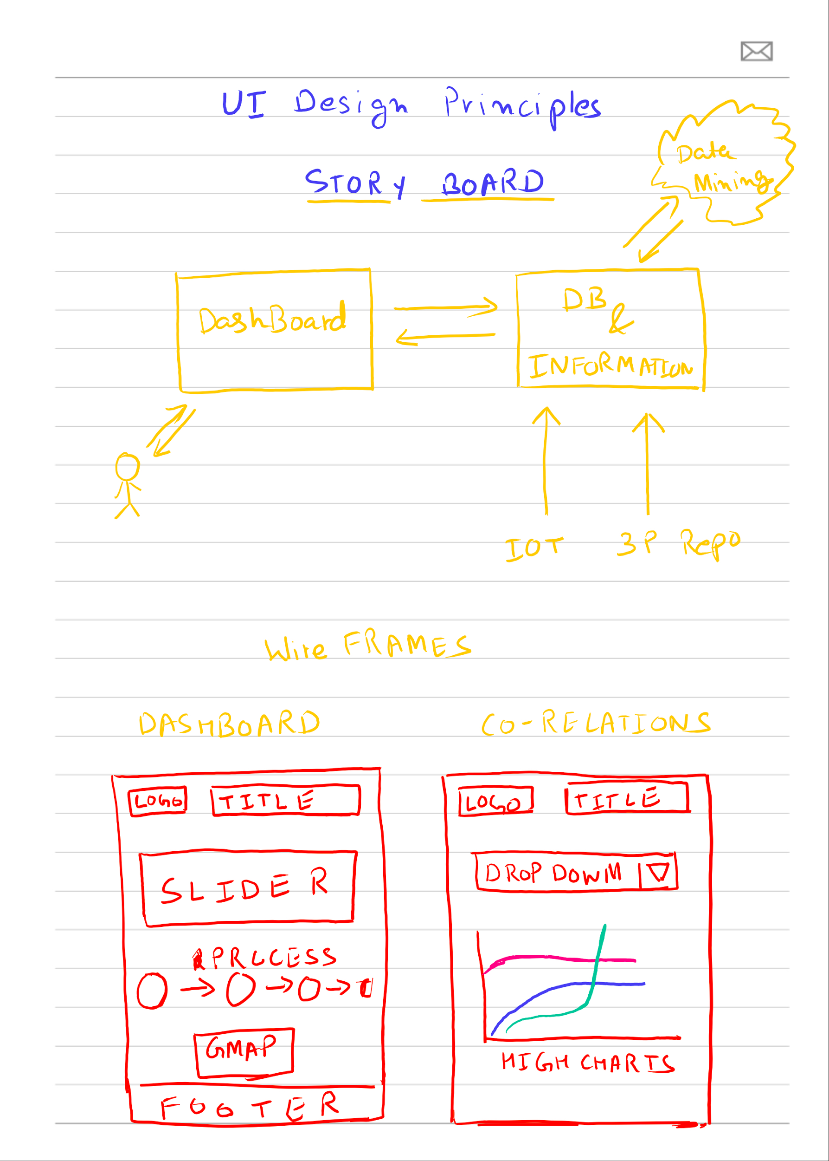  
  
  
DashBoard - Process Flow Component  
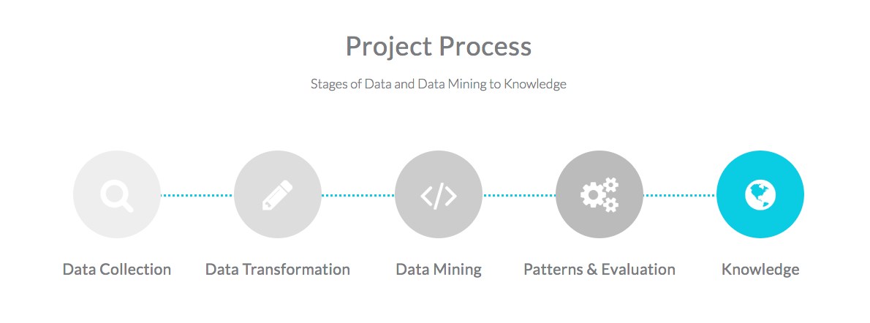

### High Level Architecture Design

The High level Architecture is described in following components:-

1. Data Sources - Data is being gathered from third party repositories (Cencoos / ERDDAP) and IOT device which is built using raspberry pi and temperature / pH sensor on it.
2. Data Collection, Cleaning & Transformation - Data is being collected using module written in NodeJS. The Data is stored in MongoDB after applying cleaning on it. Later on data is transformed and reduced into smaller set and stored in DashDB.
3. DashDB / Data Warehouse - work as warehouse, and keep data which is consumed in data mining.
4. Analytics - R analytics is ran on data and mining is done. Few clustering algorithms and regressions are applied at this stage.
5. Patterns & Evaluations - The analytics results from previous steps can be visualized using graphs and correlations are derived at this stage.
6. Recommendation - Based on the study from Step 5, recommendations are drawn which are consumed by Government and Bay Keepers.

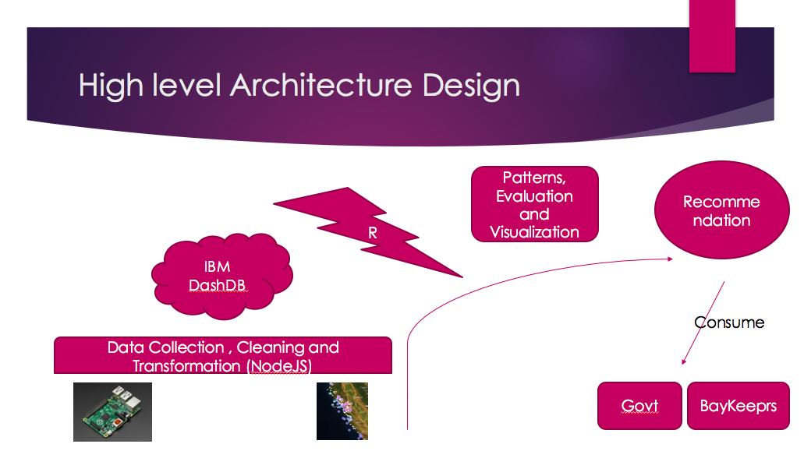

### Datasets & Data patterns

**Data Set is - Cencoos**

The Central and Northern California Ocean Observing System (CeNCOOS) is a collaborative that enables sustained and coordinated measurements, model nowcasts and forecasts, and integrated products to inform decisions about our regional ocean.  
Data is being collected from various sensors along the california pacific coast.  
  
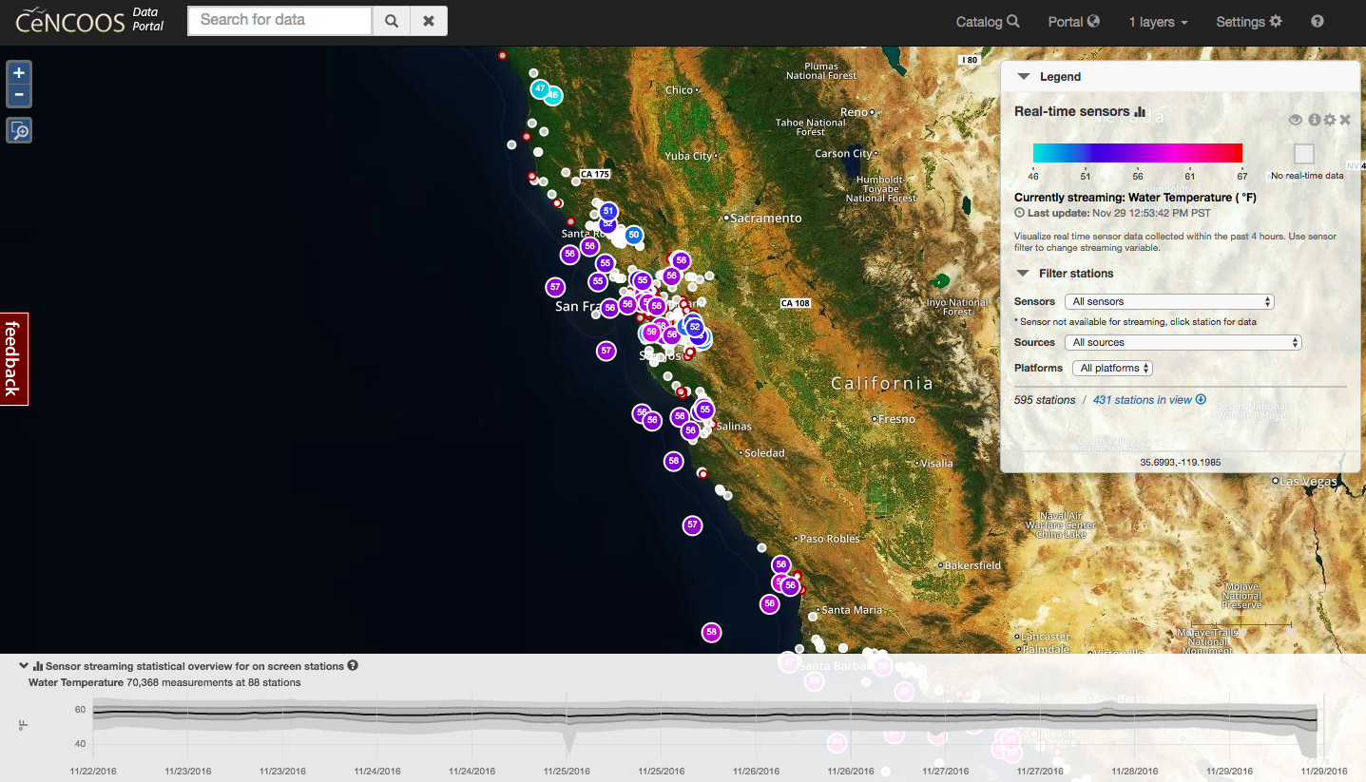

Data is also connected from our IOT device which is a temperature sensor and raspberry pi.

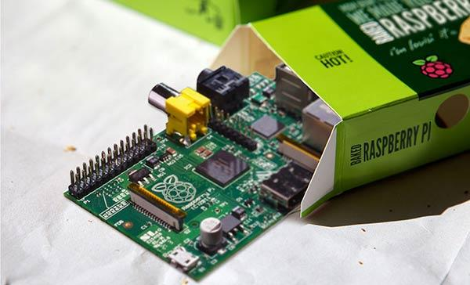

**Data Formats and Patterns**  
Data is collected in following formats

1. HTML Format 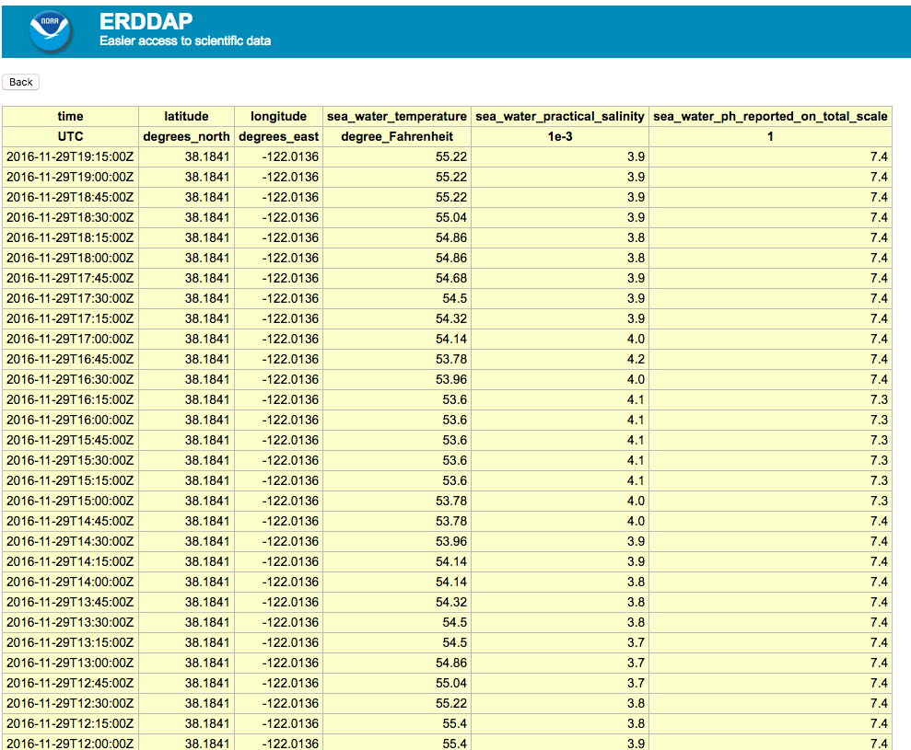
2. CSV Format of Data  
     
   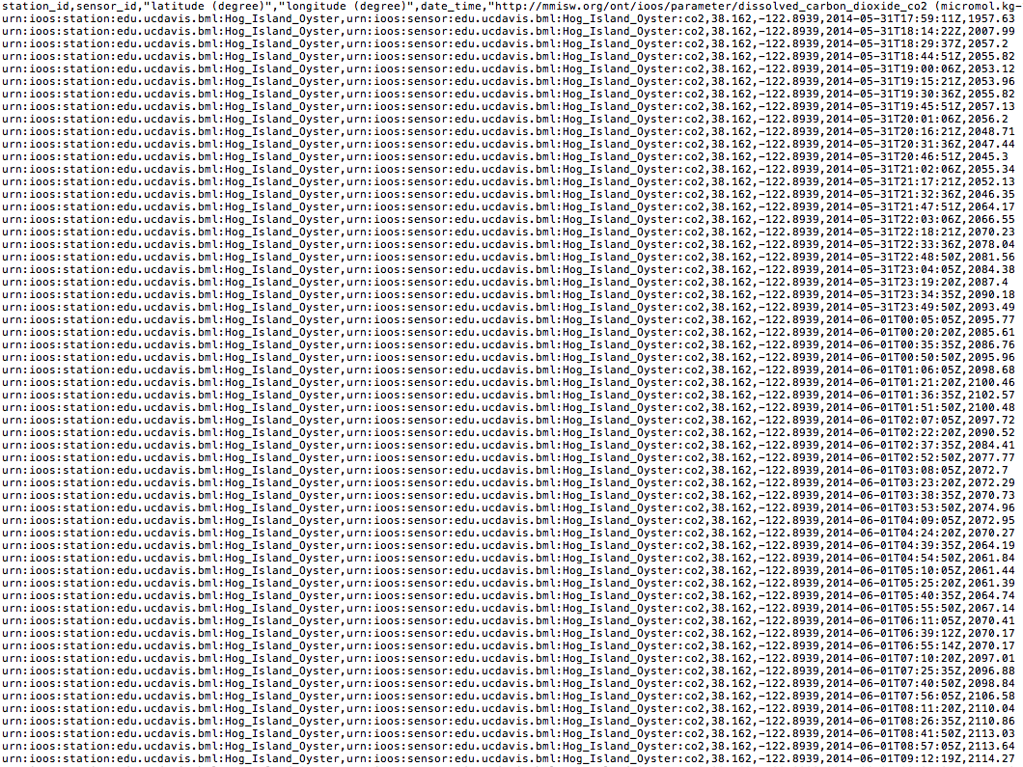
3. JSON format  
   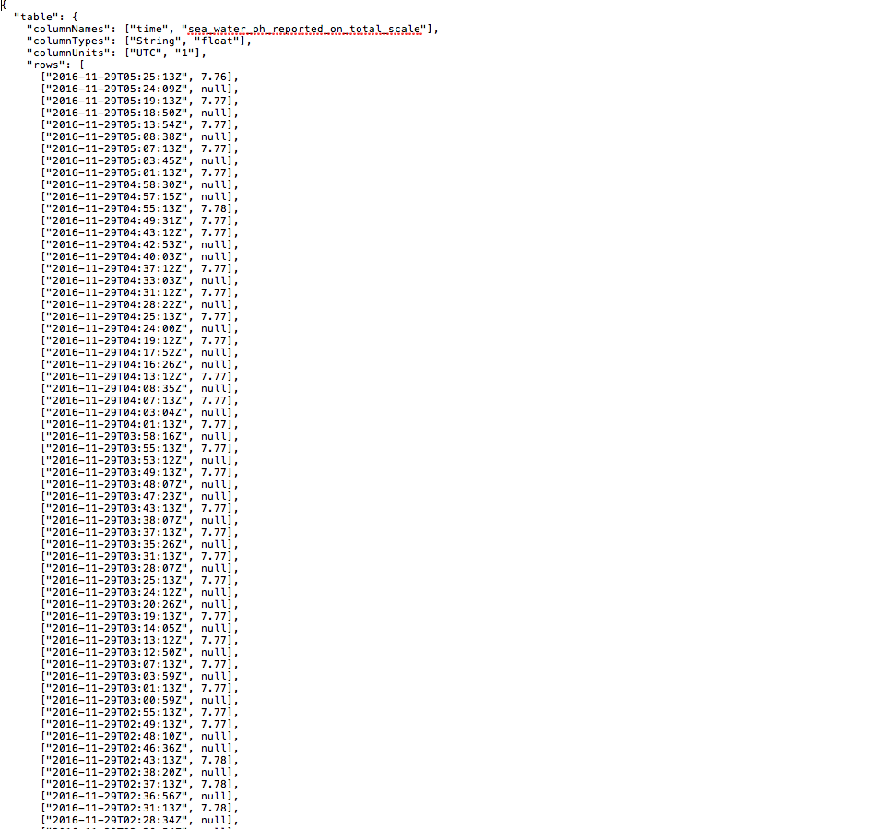

### Data Flow Diagrams & Architecture

The figure shows the Data mining reference architecture:

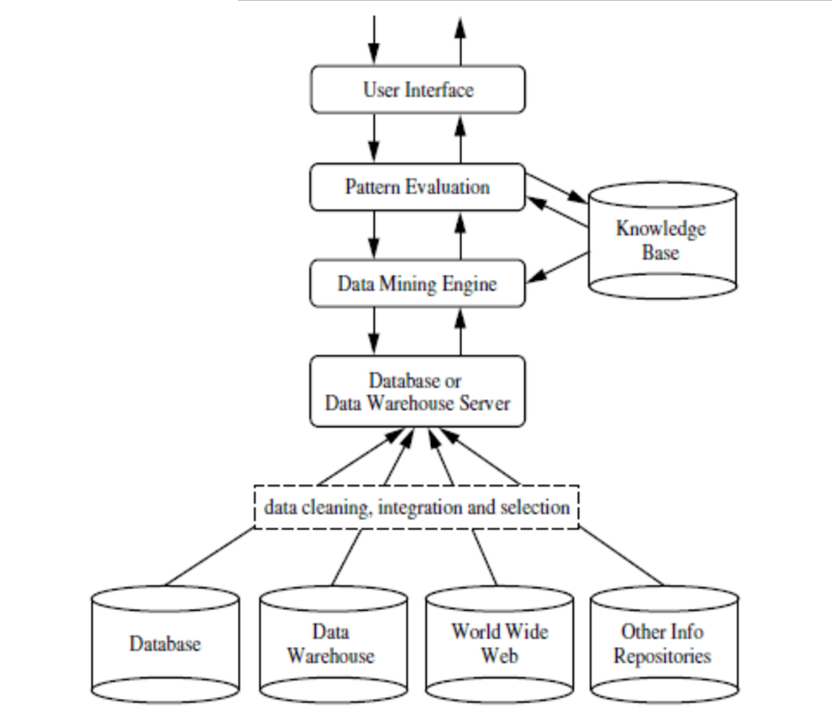

Co-relating with the above architecture and forming the MHRS architecture

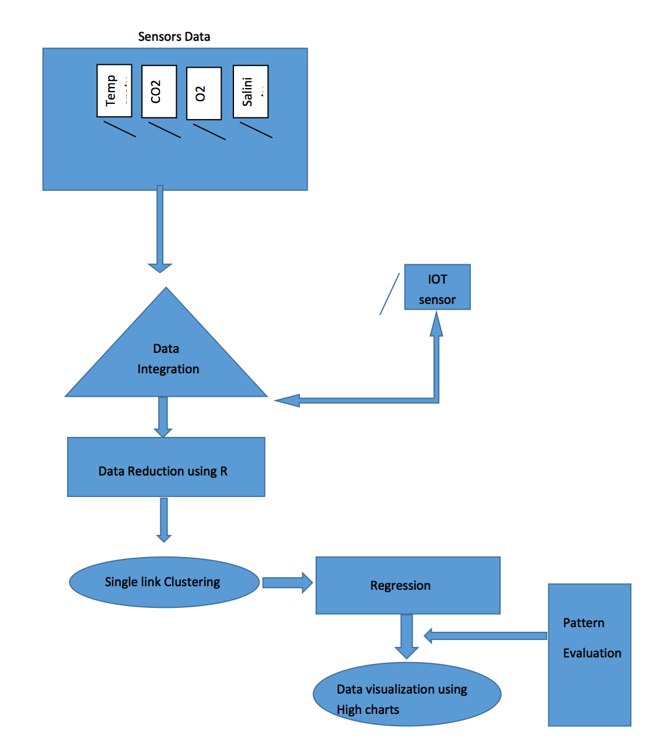

Data flow diagram

Following steps describe the data flow of our project:

1. Data stream is collected from data.cencoos.org. It is a central repository of oceanic sensor data and maintains the different kind of sensors to collect data of oceanic parameters like salinity, temperature, CO2, O2, currents etc.
2. The data is stored in mongo db at a central place using API provided by data.cencoos.org.
3. Here data from multiple sources like volunteers, private sensors, public organizations could be integrated.
4. Different methods of data cleaning and transformations are applied on raw data. Multiple data sources are integrated.
5. Cleaned data is saved to warehouse hosted in IBM dashdb.
6. Dasbdb data is processed in various ways. Here we use R analytics to do regression analysis, clustering single link
7. Found patterns and correlations are then visualized using graphs, charts and dendrograms.
8. User can see patterns and use this analytics to make economic and health related decisions.

### Data Mining Principles & Algorithms

**a. Data integration from various sources**

The first step includes data integration from all sensors like Temperature, Carbon dioxide, Salinity, pH. The figure shows the various sensors values versus time plots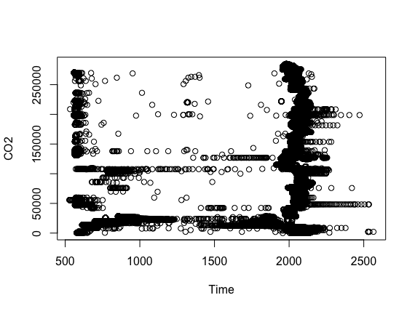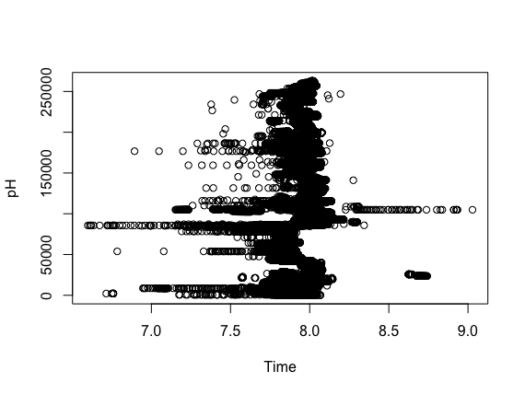

Carbon dioxide vs time pH versus time

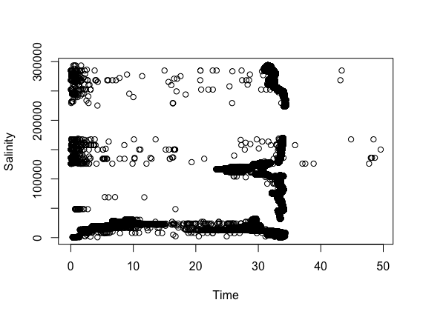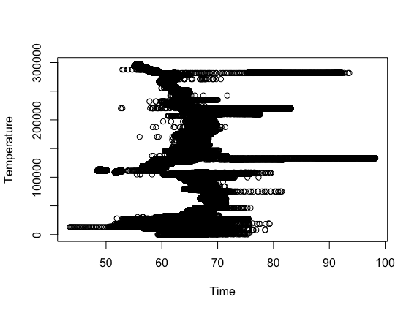

Salinity versus time Temperature versus time

**b. Data Reduction and Transformation**

The second step includes reduction of data from the original data, This can be achieved by removing noise, redundant data and low variance data. The figure shows the data reduction achieved on all the sensor values using R.

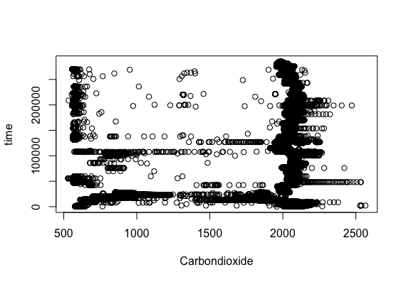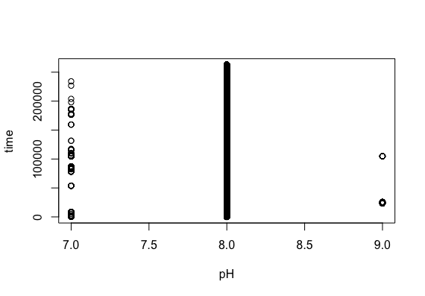

Carbon dioxide vs time pH versus time

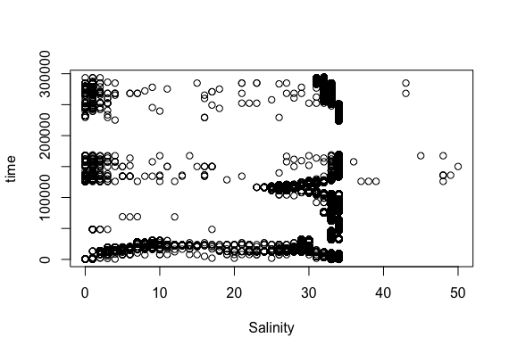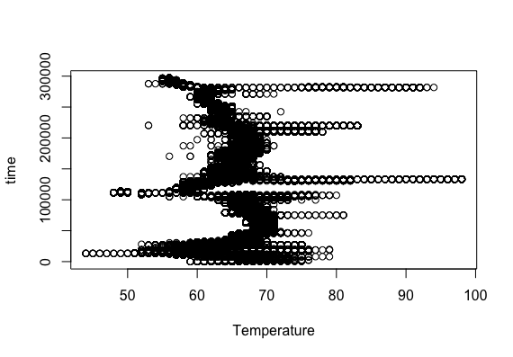

Salinity versus time Temperature versus time

**c. Clustering**

After applying single linkage clustering, complete linkage clustering and k-means clustering, we found that single linkage clustering works best for our data. Our system will run R script everytime data is updated and generate the dendrogram and cluster plot. When some data that is received falls outside of the cluster, it can be immediately seen in the cluster plot and analysis can be performed to see what is impacting this change.

For example below are the screenshots for clustering applied on CO2 data:

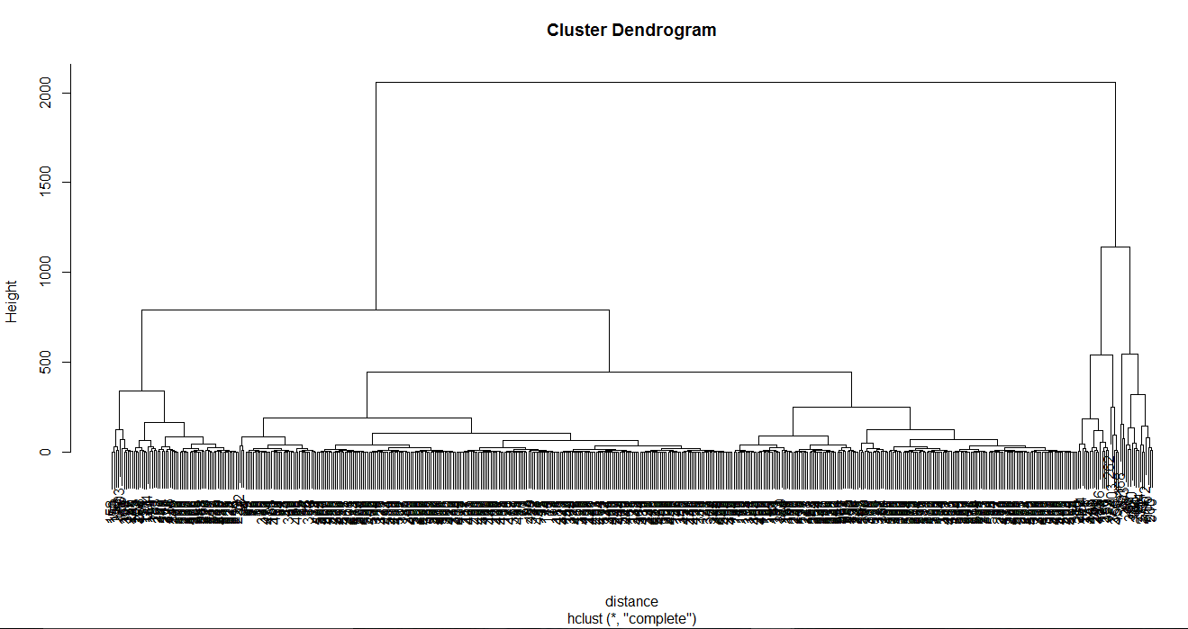

**Cluster Plot**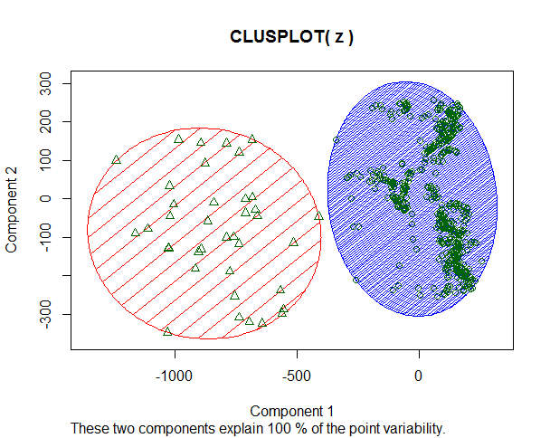

**d. Regression**

Water pH levels play an very crucial role on the water health and the marine ecosystem which includes both plants and animals. The pH levels ranges from extremely acidic to extremely basic and a neutral value of 7.0. The marine animals require a pH level of 6.5 to 9.0.

pH level of water is affected by the amount of carbon dioxide present in water. This is the result of reaction between CO2 and (H2O) water which forms (H2CO3) carbonic acid. The increase of (H2CO3) causes the pH levels of water to decrease due to the acidic nature of carbonic acid. The plants and other planktons which produce their food using photosynthesis leads to decrease in carbonic acid, increasing the pH levels.

It has been observed through various experiments that increase in water temperature leads to the increase in growth of plants. The increase in plants growth will result in an increase in process of photosynthesis leading to the reduction of CO2 from water and thus raising the pH level. The relation shows that the different parameters are linearly correlated to each other. This can be achieved using linear regression and the summary is as follows:

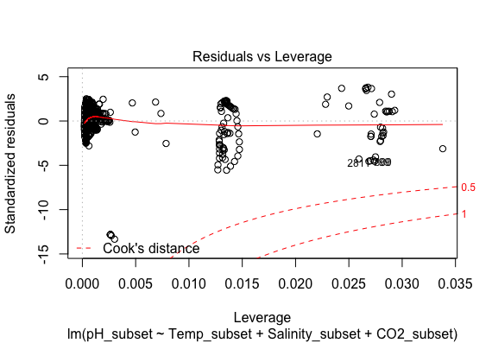

### KDD Principles

KDD or the Knowledge Discovery in Databases is the process of finding relevant information from raw data. The Knowledge Discovery in Databases (KDD) process is commonly defined with the stages:

(1) Selection

(2) Pre-processing

(3) Transformation

(4) Data Mining

(5) Interpretation/Evaluation.

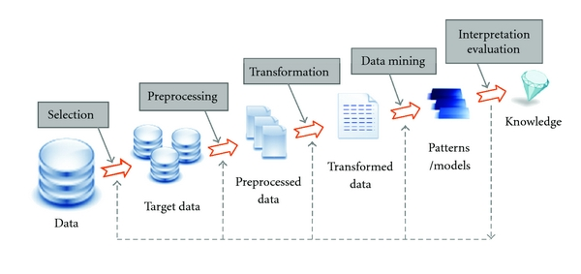

A simplified process consists of steps such as (1) pre-processing, (2) data mining, and (3) results visualization.

**Preprocessing**

Before any processing can be done the target dataset must be cleaned and transformed to prepare it for data analytics process. The oceanic sensors send data of ocean parameters like salinity, temperature, dissolved CO2 and O2 every 30 minutes. As this data has been collecting since year 2003 so we have data of about 13 years and collection frequency being high we have lots of data.

1. We are taking average values for each day for each attribute using mean formula.

*Value of day = Sum of all values / Number of values collected*

1. Ignore days for which no value was reported
2. Huge anomalies in data should be filtered out

**Data mining**

This process finds value or information from the data that is the result of preprocessing stage. The Data mining pertains to using tools like R or Numpy to find correlations, associations and dependencies in data. These tools also help in find the variability factor among different attributes which may seem independent to user but only show relation after some processing has been done. Data mining also uses clustering and regression to find similar set of data points.

We have used k-mean clustering and linear regression through R language to do data mining. We found the correlation between salinity and set of parameters like temperature, dissolved CO2 and O2.

**Result Visualization**

The results of data mining are being visualized using high charts graphs and using visualization tools of R language. The results are then put onto the web portal that can be referenced by concerned parties.

### Data Tools Used

|  |  |
| --- | --- |
| Title | Description |
| Frontend | AngularJS, BootStrap, HTML5, CSS |
| Backend | NodeJS |
| Database/ Warehouse | MongoDB, DashDB |
| Analysis | R programming |
| Tools | RStudio, IntelliJ |
| Processing Framwork | Hadoop Map-Reduce |
| Website Hosted | IBM Bluemix |

### Client Side Design

**Client side Design** - The main component is the dashboard and the visualization. Following Technologies are used for client side design  
1. Bootstrap  
2. Angular JS  
3. High Charts  
4. HTML / CSS / Javascript (Foundation)  
  
Following are the client design which we have developed.

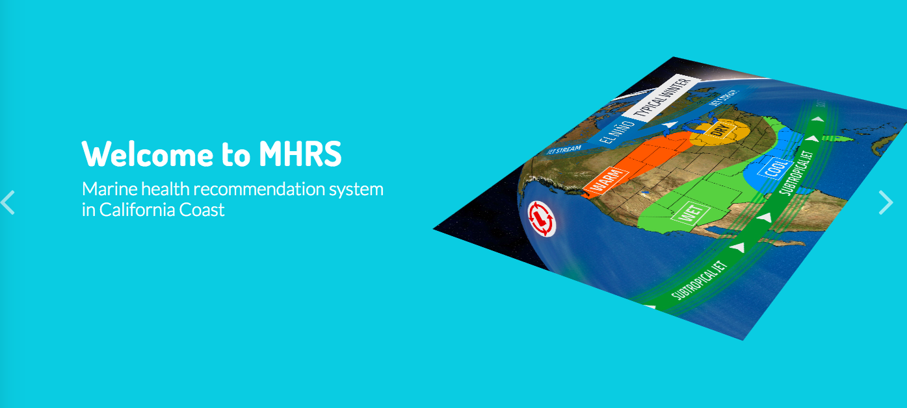  
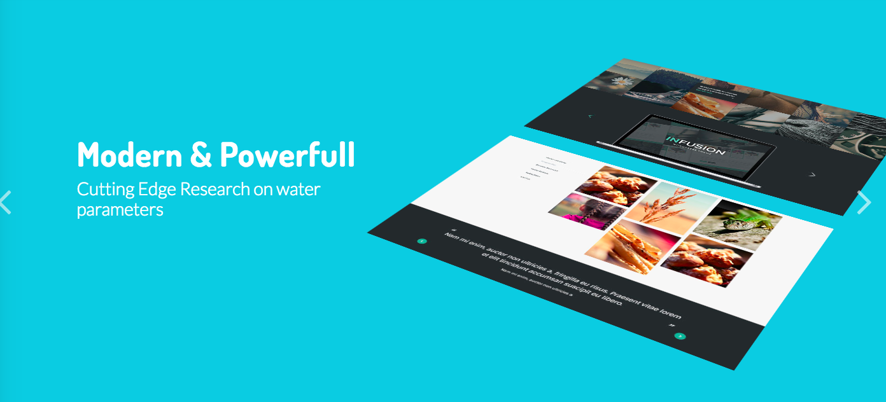

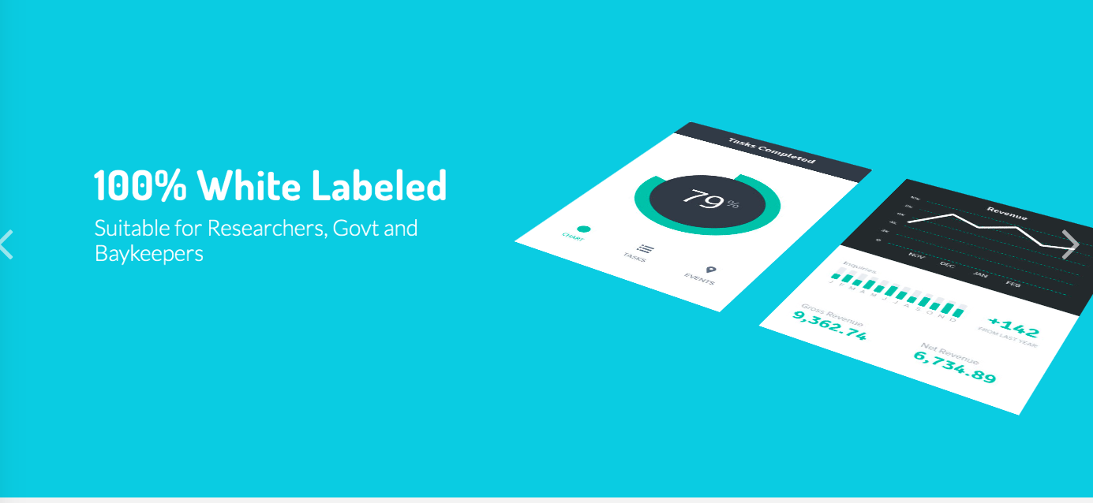

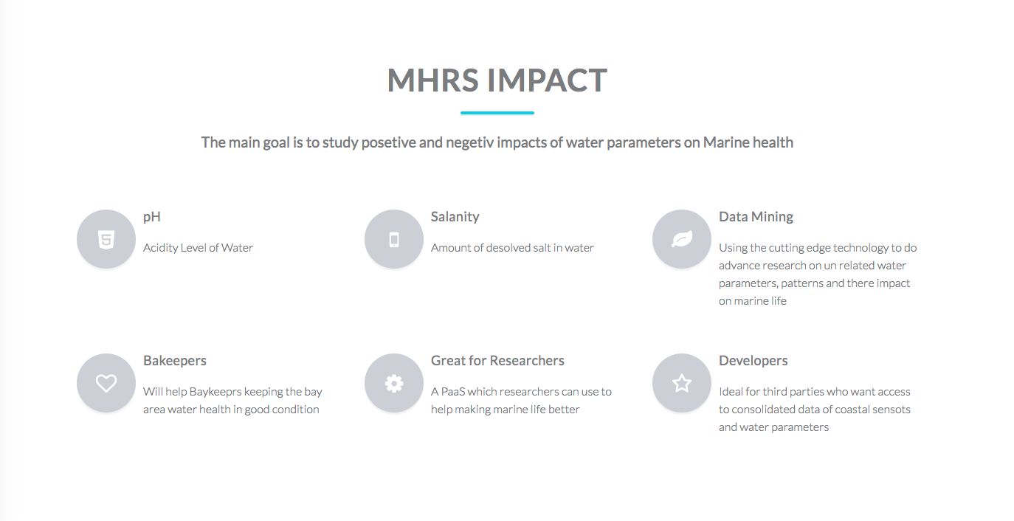

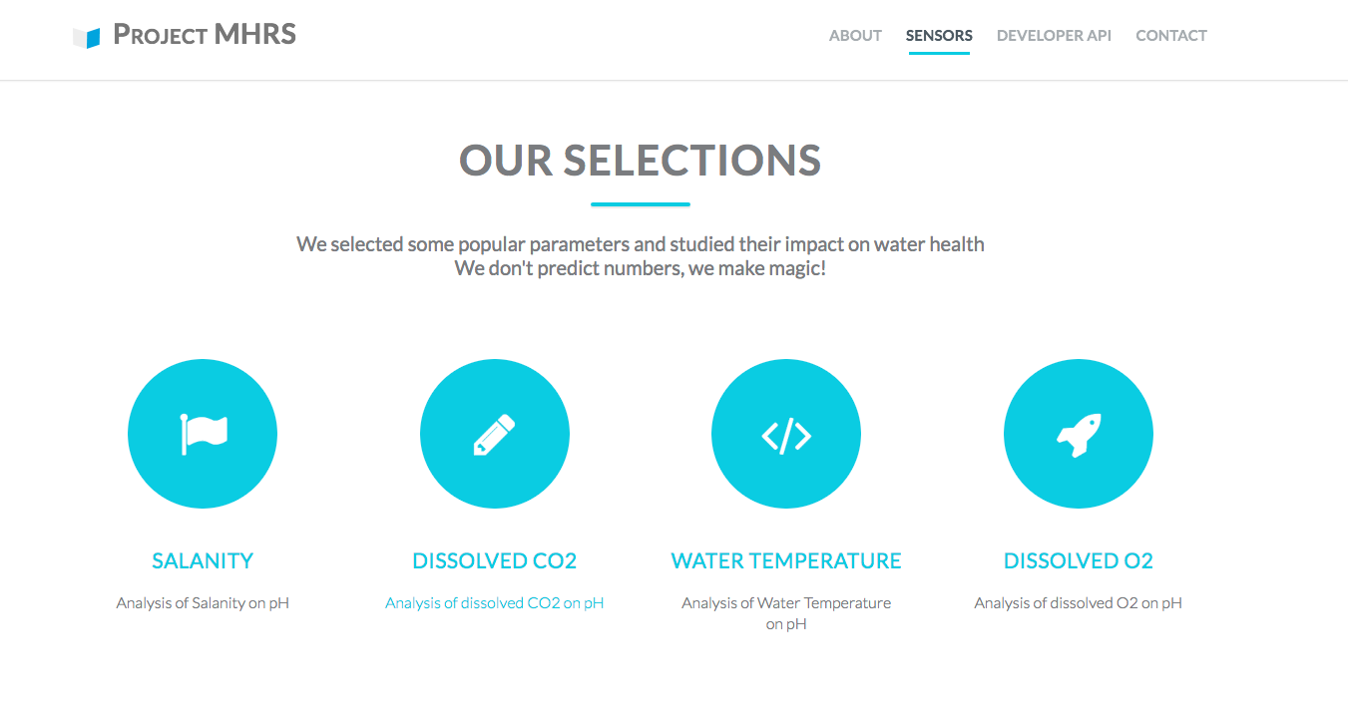

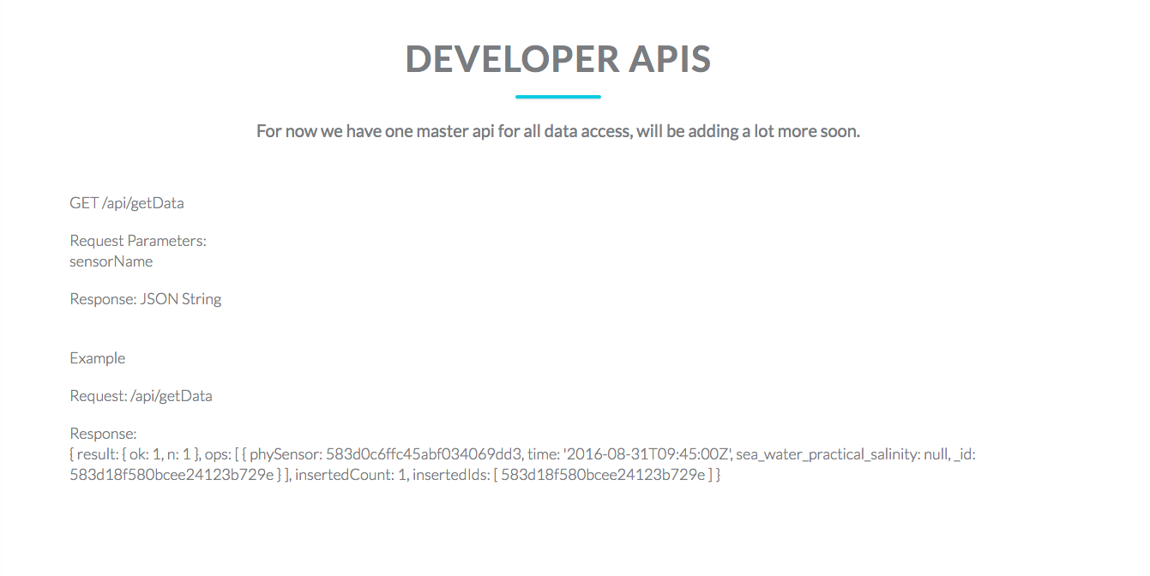

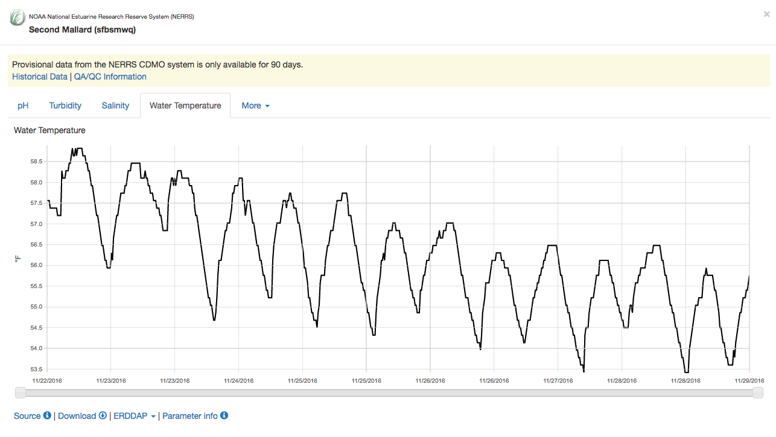

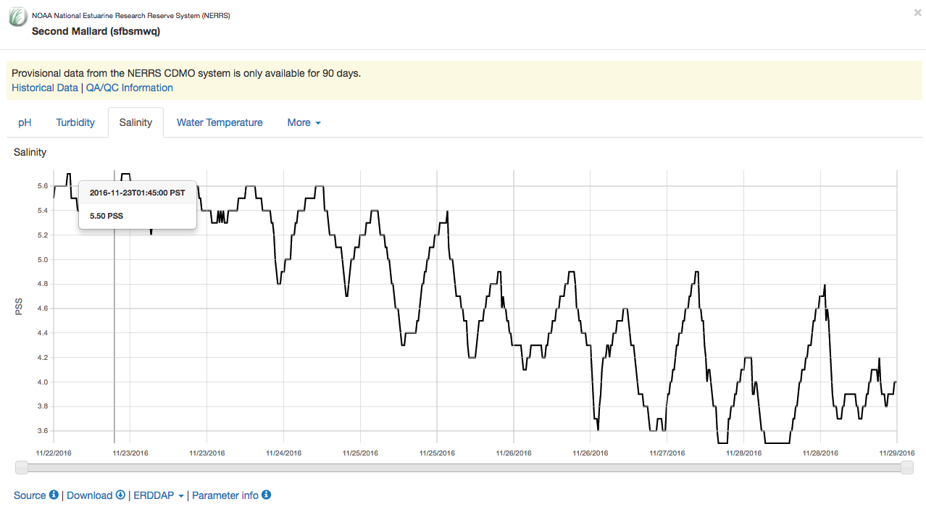

### Testing (UI or Stress test)

**Unit Test Case:**

We have written few test cases which are ran before running the whole project. These are sanity test cases which check minimal liability of the project.

Few of the sample test cases are mentioned below.

**testRepo()** - Test the availability of the third marty repository to start fetching of data.

testDbConnectivity() - Test the availability of the database.

function testRepo() {

console.log("Running Test testRepo()");

var remoteRepoHost = "http://erddap.cencoos.org/erddap/tabledap";

requestModule(remoteRepoHost, function (error, res, body) {

assert(res.statusCode != 200);

console.log("testRepo() - Success");

});

}

function testDbConnectivity() {

console.log("Running Test testDbConnectivity()");

MongoClient.connect("mongodb://localhost:27017/cmpe239").then(function(db) {

assert(db != null);

console.log("testDbConnectivity() - Success");

return;

});

}

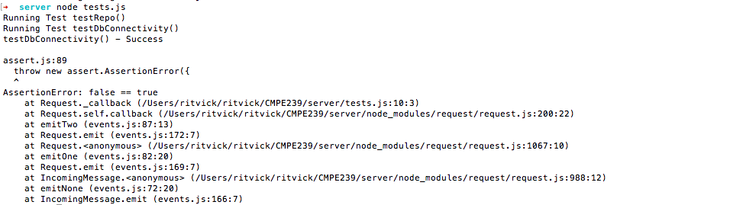

**Load / Stress Test**   
For load test we used third party framework : <http://loadimpact.com> to test the raspberry api end point and getData endpoint and our dashboard.

This load test can generate virtually unlimited traffic. Below is the snippet of the test we ran after hosting our project on IBM bluemix.

The load is generated from Europe servers to check the zone availability and the virtual users capacity of the system.

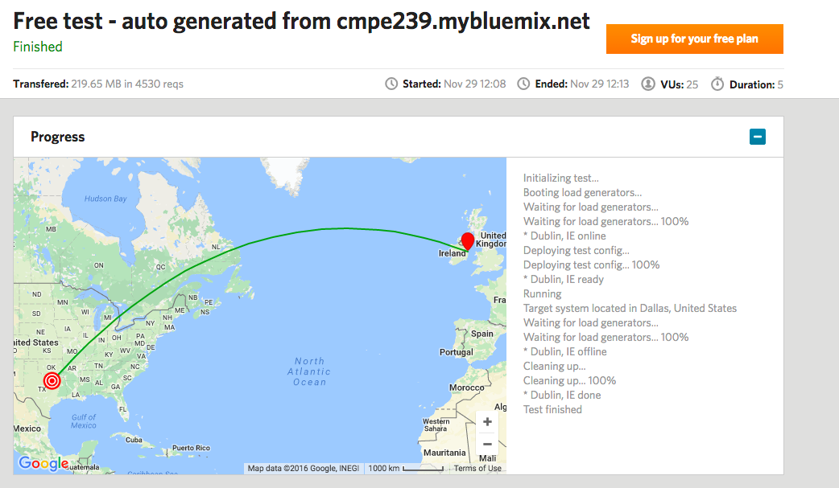  
  
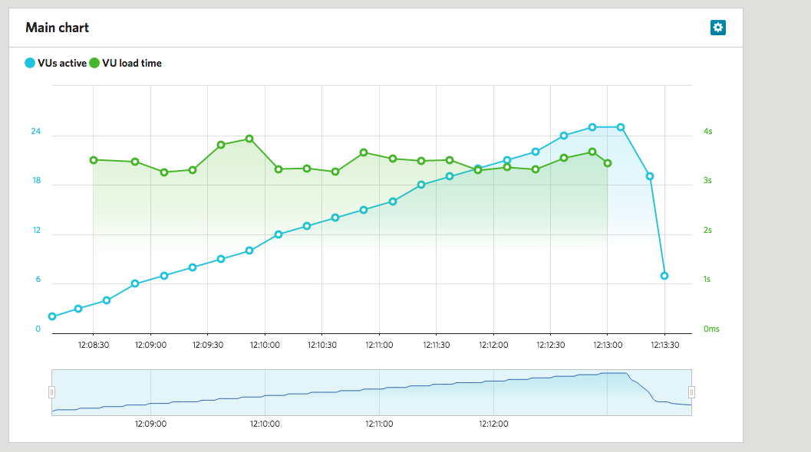  
  
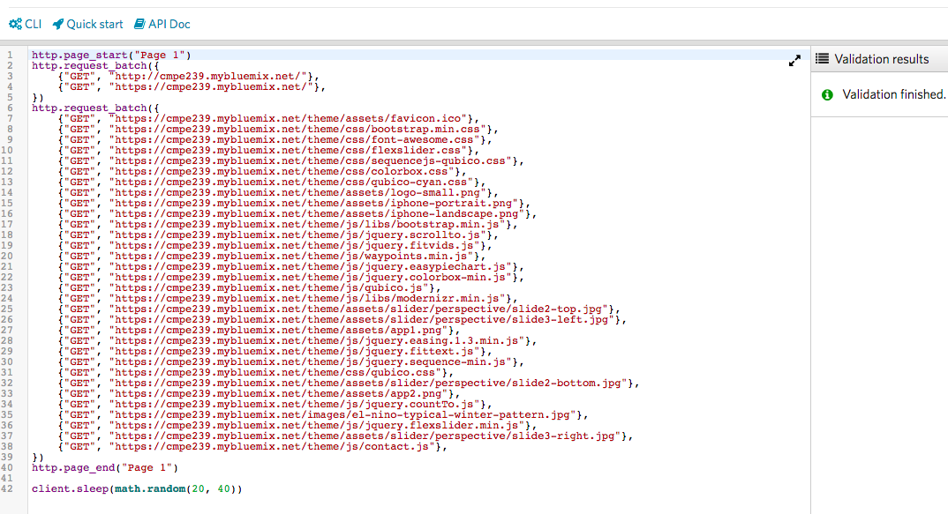  
  
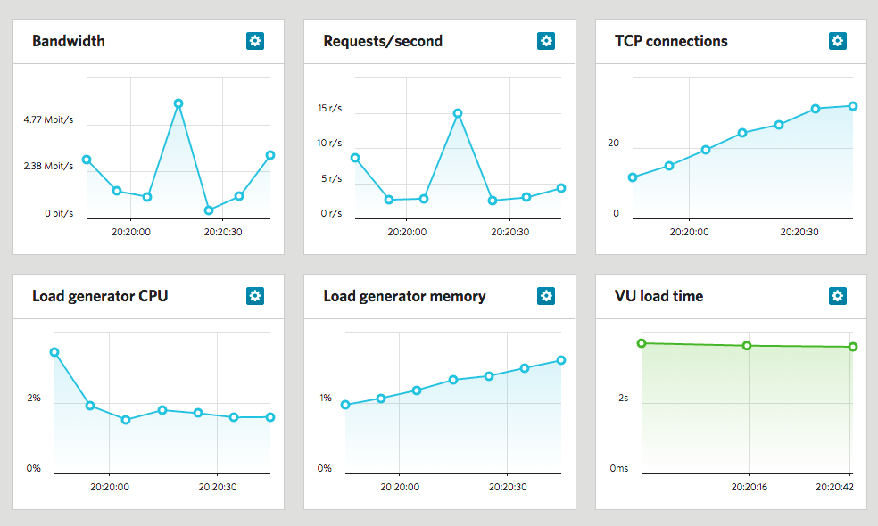  
  
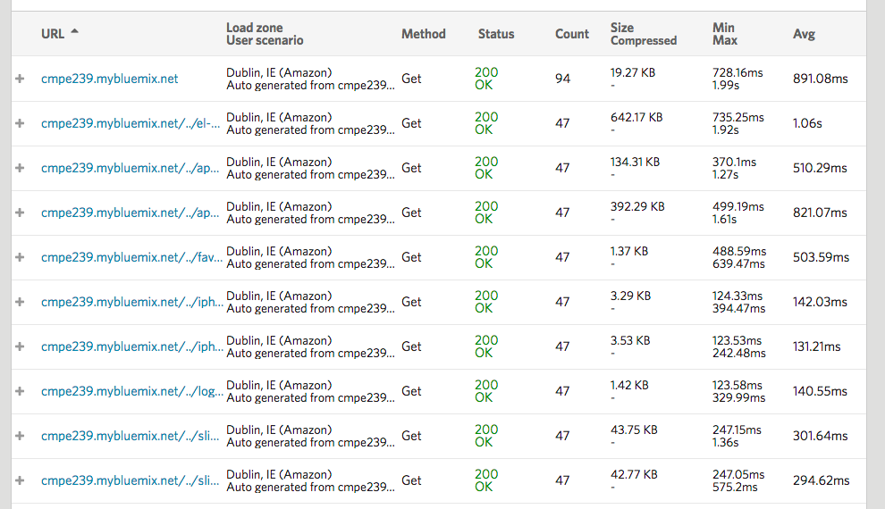

### Design Patterns Used

As per wikipedia “In engineering, a design pattern is a general reusable solution to a commonly occurring problem within a given context in software design. It is not a finished design that can be transformed directly into source or machine code. It is a description or template for how to solve a problem that can be used in many different situations. Design patterns are formalized best practices that the programmer can use to solve common problems when designing an application or system.” Following are the design patterns we have used to implement our solution to the data analysis problem:

1. **Front End** - We have used Publish/Subscribe pattern. The PubSub promotes loose coupling and is easier to scale. One thing to keep in mind that since subscribers and publishers are loosely coupled, if any subscriber fails due to any any exception the publisher won't even know. Using widely available RESTful methods like GET, POST, PUT and DELETE, the PubSub pattern can be implemented easily. The front end in this pattern is generally a single page app that polls data from backend cloud application over HTTP and only handles the data visualization and transformation.  
     
   Endpoint to poll data from prototype sensor built using raspberry pi  
    *GET /raspberryApi*

Endpoint to collect data

*POST /getdata*

1. **Middle Tier** - We are using **memcache** as our middle tier to store the analysis results from backend data store. Memcache APIs provide a very large hash table distributed across multiple machines. When the table is full, subsequent inserts cause older data to be purged in least recently used (LRU) order. Applications using Memcached typically layer requests and additions into RAM before falling back on a slower backing store, such as a database. We are also using **R language** to process the data in middle tier. We are also using **mongoDB** as middle tier database to store raw data before processing.
2. **Data Store** - We are fetching the data from [**www.data.cencoos.org**](http://www.data.cencoos.org) and storing it in **IBM dashDB**. Dashdb provides data base as a service for warehousing of data and also provides means to do in memory analytics for faster processing of data. DashDB is hybrid database with configurations that are optimized for either transactional or data warehouse workloads.
3. **Cloud** - We are using the cloud infrastructure of **IBM bluemix**. Using bluemix services makes it easy to ingest and process data, visualize it and do R analytics on it using inbuilt dashDB services.

### Presentation

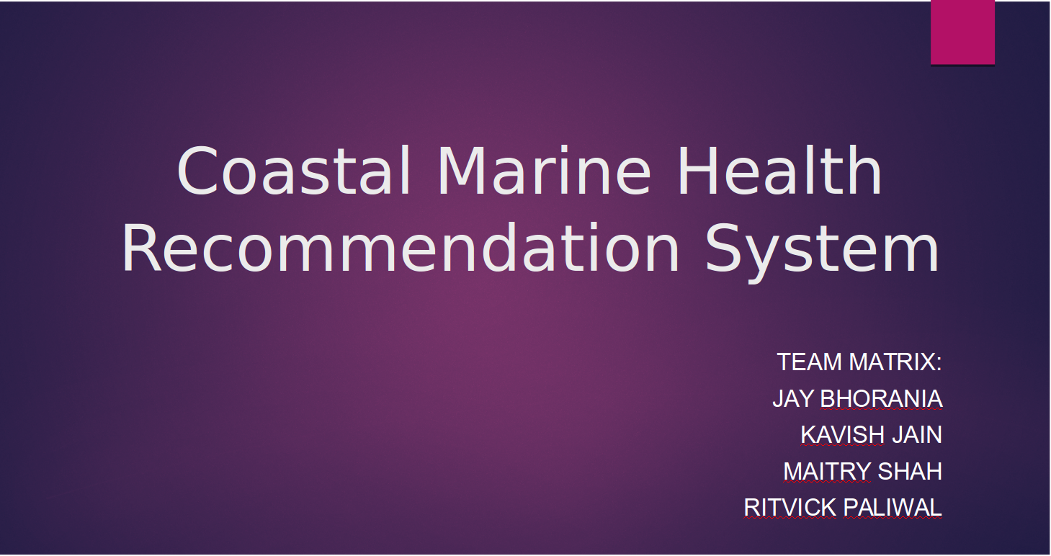

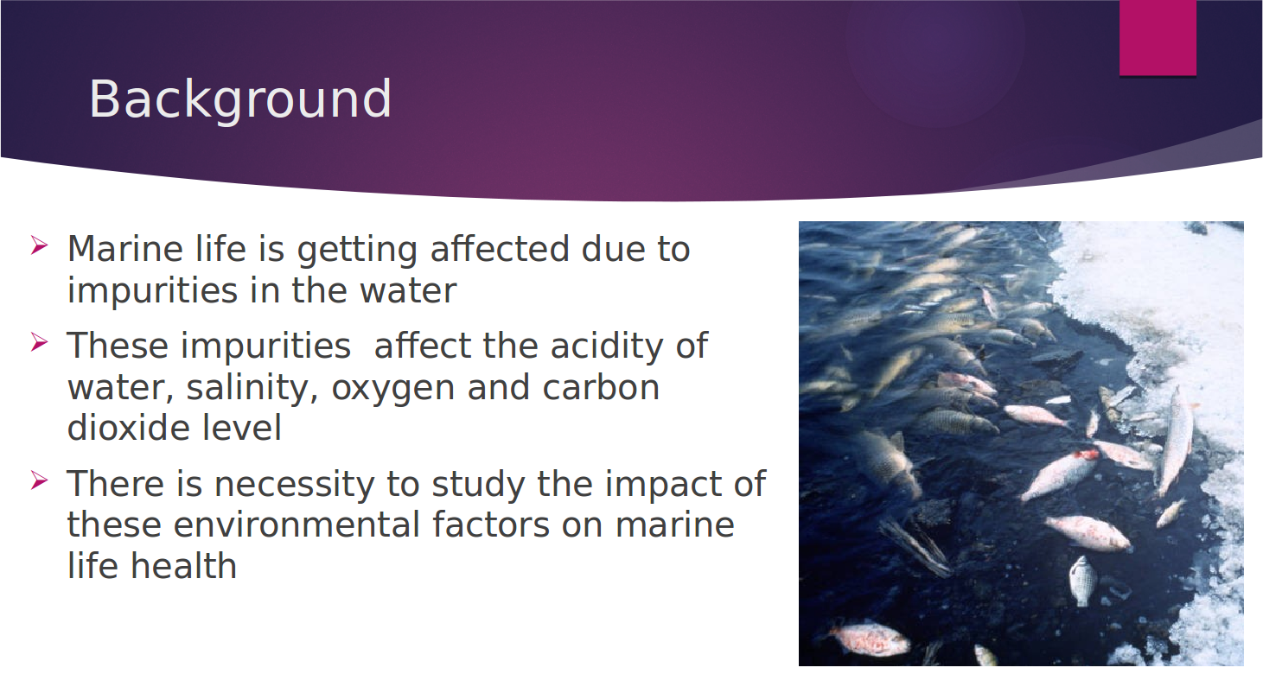

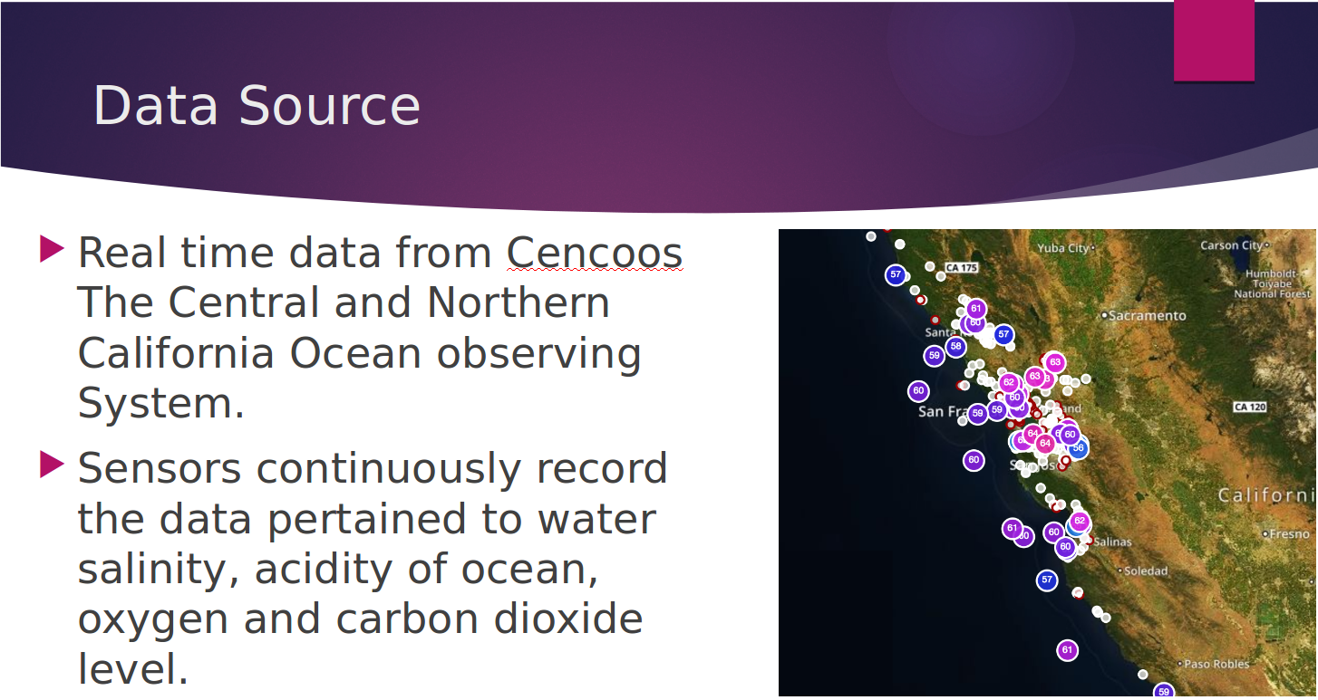

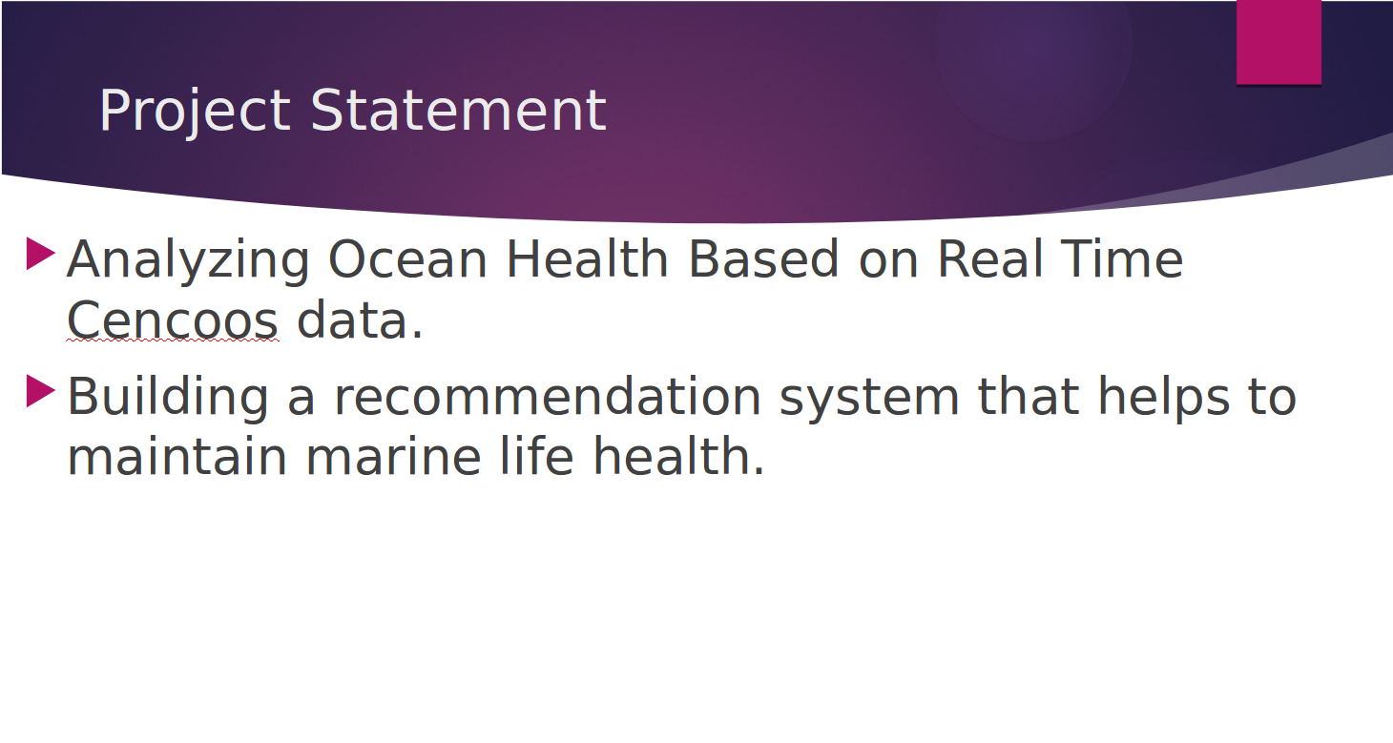

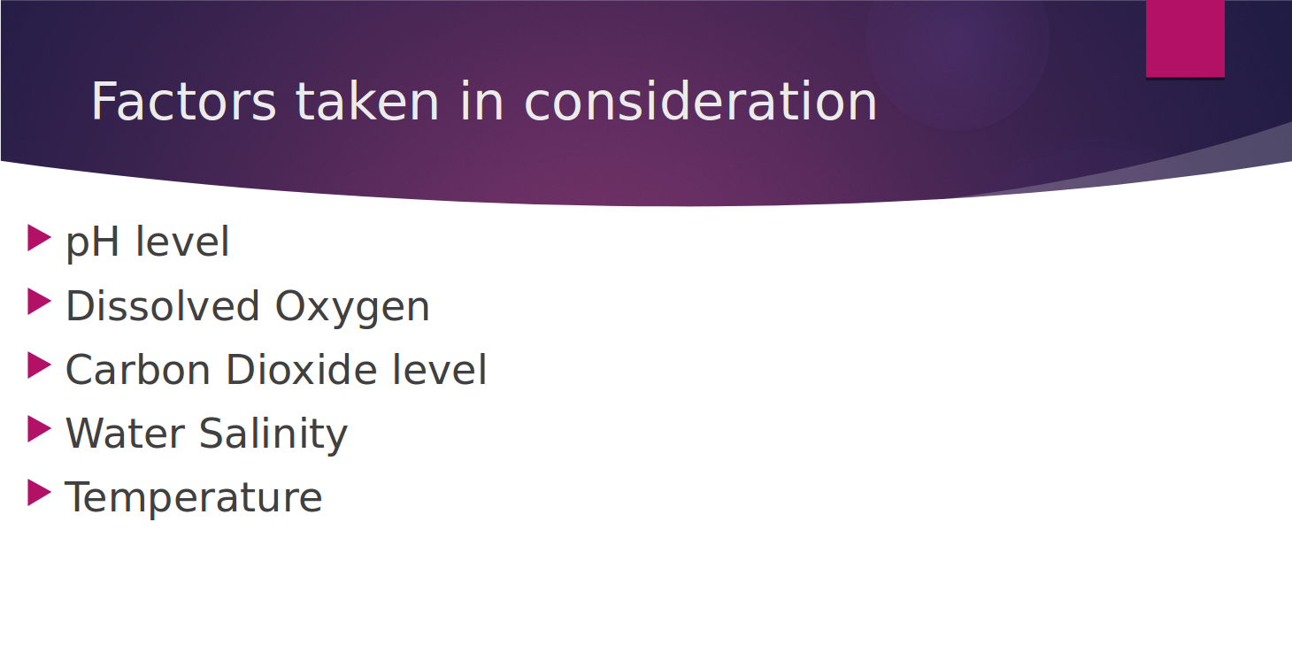

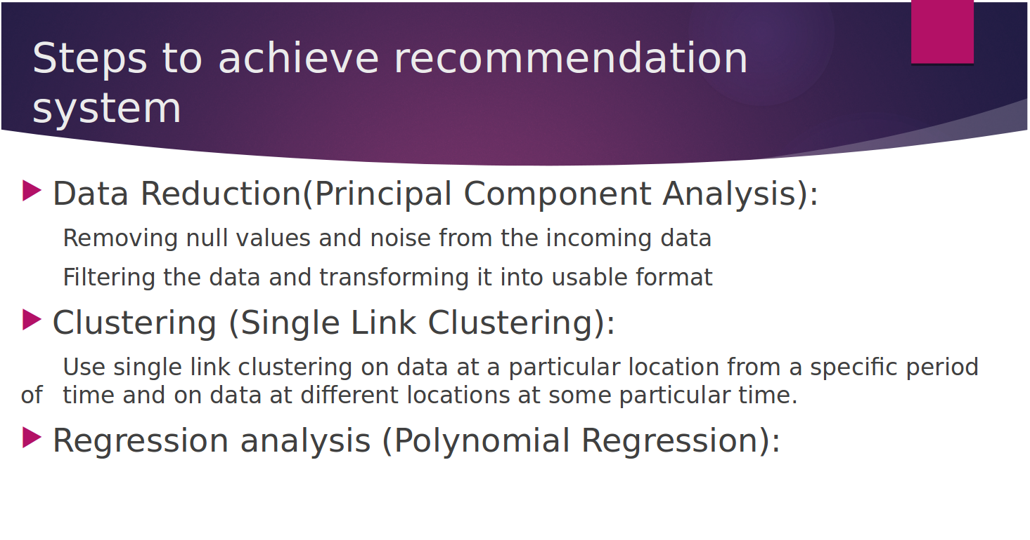

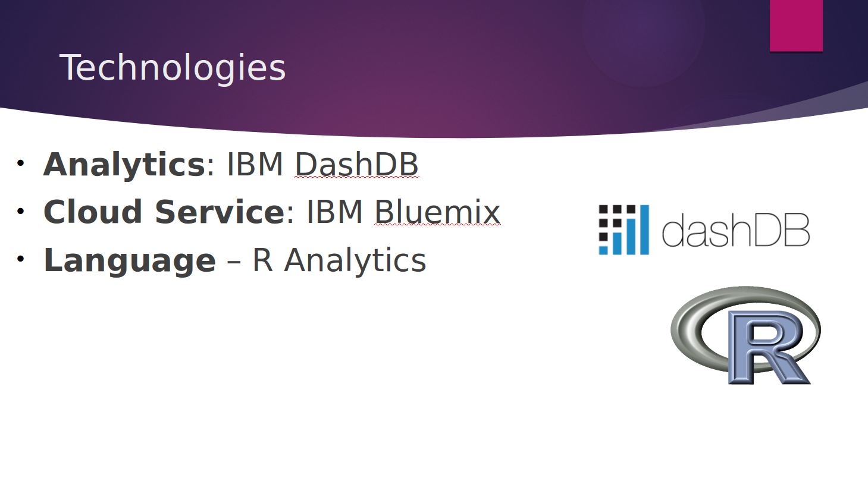



### Team Contribution

**Jay Mansukh Bhorania**: - Data Collection (using CSVs, MongoDB), Cleaning and Transformation, R analysis for data cleaning and clustering with CSV and MongoDB data.

**Kavish Jain**: - Visualization charts, User interface (AngularJS and Bootstrap), Hadoop Map-Reduce (Python) and IBM dash DB

**Maitry Shah**: -Correlation between different sensor parameters, Data Integration and Reduction using Rstudio, Regression for various sensor parameters.

**Ritvick Paliwal**: - Data Collection (using APIs), Cleaning and Transformation. Data migration to warehouse. Website / Dashboard with graphs using High-Charts, Unit Tests, stress test, deployment to IBM bluemix, Recommendation Alerts.